### 

### Semester One Examination, 2018

### Question/Answer booklet

# MATHEMATICS

**UNIT**

## Section Two:

## Calculator-assumed

Your Name

Your Teacher’s Name

## Time allowed for this section

Reading time before commencing work: ten minutes

Working time: one hundred minutes

## Materials required/recommended for this section

***To be provided by the supervisor***

This Question/Answer booklet

Formula sheet (retained from Section One)

***To be provided by the candidate***

Standard items: pens (blue/black preferred), pencils (including coloured), sharpener, correction fluid/tape, eraser, ruler, highlighters

Special items: drawing instruments, templates, notes on two unfolded sheets of A4 paper, and up to three calculators approved for use in this examination

## Important note to candidates

No other items may be taken into the examination room. It is **your** responsibility to ensure that you do not have any unauthorised material. If you have any unauthorised material with you, hand it to the supervisor **before** reading any further.

|  |  |  |  |  |  |
| --- | --- | --- | --- | --- | --- |
| Question | Mark |  | Question | Mark |  |
| 7 |  | 6 | 13 |  | 14 |
| 8 |  | 11 | 14 |  | 5 |
| 9 |  | 10 | 15 |  | 8 |
| 10 |  | 8 | 16 |  | 12 |
| 11 |  | 8 | 17 |  | 5 |
| 12 |  | 10 | 18 |  | 3 |

**Structure of this paper**

|  |  |  |  |  |  |
| --- | --- | --- | --- | --- | --- |
| Section | Number of questions available | Number of questions to be answered | Working time (minutes) | Marks available | Percentage of examination |
| Section One:  Calculator-free | 6 | 6 | 50 | 50 | 35 |
| Section Two:  Calculator-assumed | 12 | 12 | 100 | 100 | 65 |
|  |  |  |  | **Total** | 100 |

**Instructions to Candidates**

1. The rules for the conduct of the Western Australian Certificate of Education ATAR course examinations are detailed in the *Year 12 Information Handbook 2018.* Sitting this examination implies that you agree to abide by these rules.
2. Write your answer in this Question/Answer booklet.
3. You must be careful to confine your answers to the specific questions asked and to follow any instructions that are particular to a specific question.
4. Additional pages for the use of planning your answer or continuing your answer to a question have been provided at the end of this Question /Answer booklet.If you use the space to continue an answer , indicate in the original answer space where the answer is continued.
5. **Show all your working clearly.** Your working should be in sufficient detail to allow your answers to be checked readily and for marks to be awarded for reasoning. Incorrect answers give without supporting reasons cannot be allocated any marks. For any question or part question worth more than two marks, valid working or justifiation is required to receive full marks. If you repeat any question , ensure that you cancel the answer you do not wish to be marked.
6. It is recommended that **YOU DO NOT USE PENCIL**, except in diagrams.
7. The Formula Sheet IS NOT to be handed in with your Question/Answer booklet.

**Section Two: Calculator-assumed (100 Marks)**

This section has twelve (**12)** questions. Answer **all** questions. Write your answers in the spaces provided.

Spare pages are included at the end of this booklet. They can be used for planning your responses and/or as additional space if required to continue an answer.

● Planning: If you use the spare pages for planning, indicate this clearly at the top of the page.

● Continuing an answer: If you need to use the space to continue an answer, indicate in the original answer space where the answer is continued, i.e. give the page number. Fill in the number of the question that you are continuing to answer at the top of the page.

Working time: 100 minutes.

**Question 7 (6 marks)**

*AB* is an interval. The coordinates of A and B are (2, 6) and (8, 6) respectively. Find:

(a) the distance *AB* (2 marks)

(b) the midpoint of *AB* (2 marks)

(c) the equation of the circle with diameter *AB* (2 marks)

**Question 8 (11 marks)**

The curve $C$ has equation $y=4x^{2}+24x+A$, where $A$ is a non zero constant.

(a) Express $y$ in the form $p{\left(x+q\right)}^{2}+r$. Hence, find the values of $p$ and $q$, and an expression for $r$ in terms of A. (4 marks)

(b) A straight line $L$ has an equation $y=Bx+10$, where $B$ is a non zero constant.

Given that $C$ and $L$ meet at the points with $x=-1$ and $x= -\frac{21}{4}$, determine the

value of $A$ and $B$. (7 marks)

**Question 9 (10 marks)**

Given $P\left(x\right)=-5x^{2}-6$ and $Q\left(x\right)=x+1$ and $R\left(x\right)=5x^{2}+3x$

(a) Simplify $P\left(x\right)+Q\left(x\right)+R(x)$ (2 marks)

(b) Simplify $Q\left(x\right)-P(x)$ (2 marks)

(c) Simplify $P\left(x\right)×R(x)$ (2 marks)

(d) Simplify $P\left(x\right)-Q\left(x\right)-R(x)$ (2 marks)

(e) Simplify $R\left(x\right)-Q\left(x\right)P(x)$ (2 marks)

**Question 10 (8 marks)**

A box contains 35 apples, of which 25 are red and 10 are green. Of the red apples, five contain an insect and of the green apples, one contains an insect. Two apples are chosen at random from the box. Find the probability that:

(a) both apples are red and at least one contains an insect. (3 marks)

(b) at least one apple contains an insect given that both apples are red. (2 marks)

(c) both apples are red given that at least one is red. (3 marks)

**Question 11 (8 marks)**

Determine the equations of the following graphs:

(a) (2 marks)

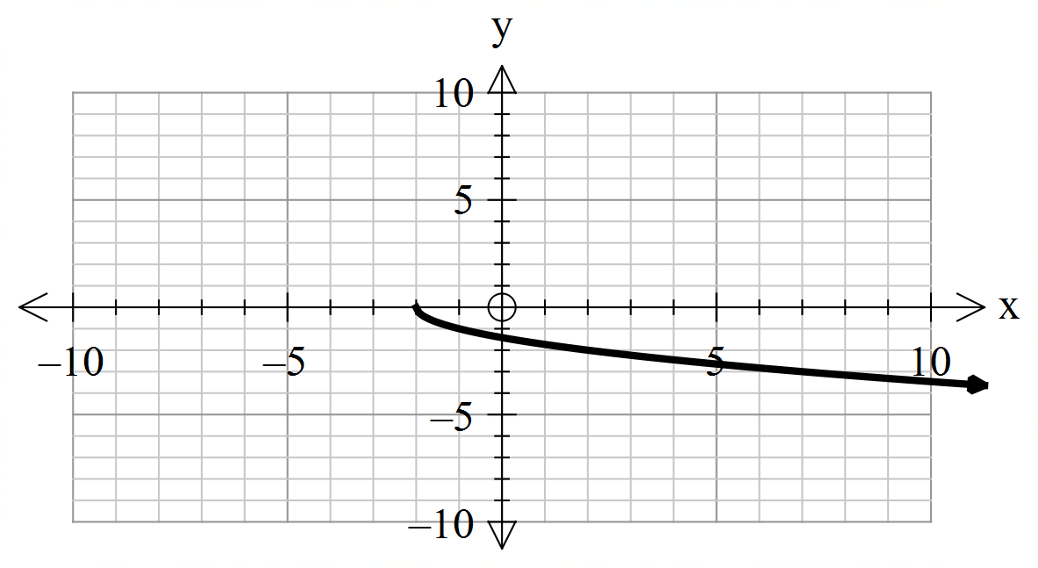

(b) (4 marks)

 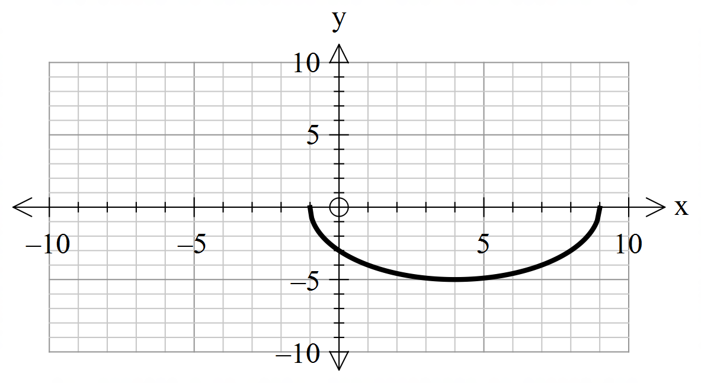

(c) (2 marks)

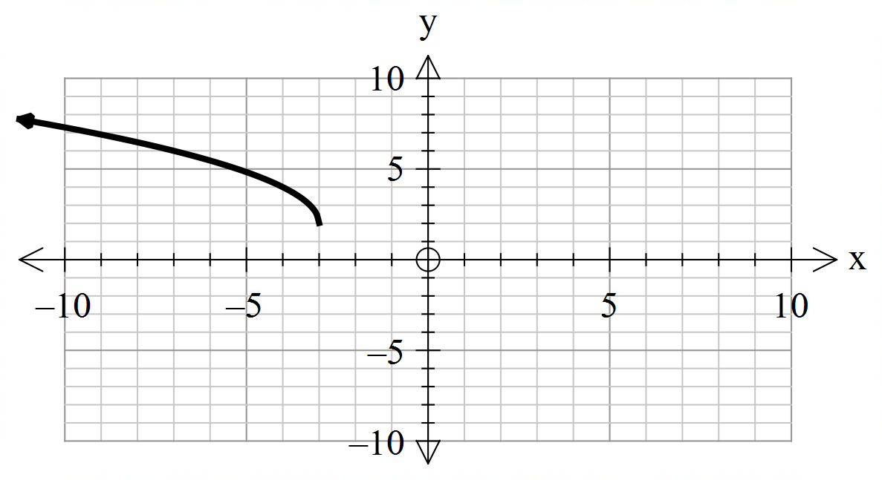

**Question 12 (10 marks)**

There are *n* beads in a bag. Six of them are green and the rest are blue. Jon picks one bead out of the bag and does not replace it. He then picks another bead at random.

1. Represent the situation above by drawing a tree diagram. (2 marks)
2. The probability of picking 2 green beads is 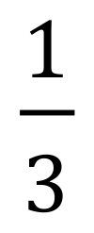.

i. Show that 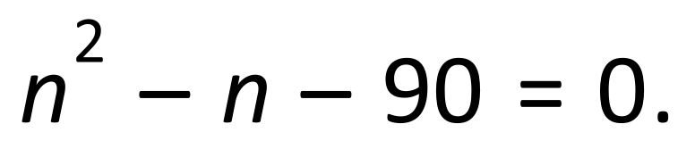 (3 marks)

ii. How many beads are in the bag? (2 marks)

iii. Find the probability of picking 2 beads of different colours. (3 marks)

**Question 13 (14 marks)**

(a) Determine the equation of the following piece-wise defined function below. (4 marks)

Let 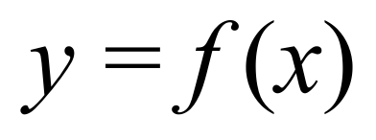.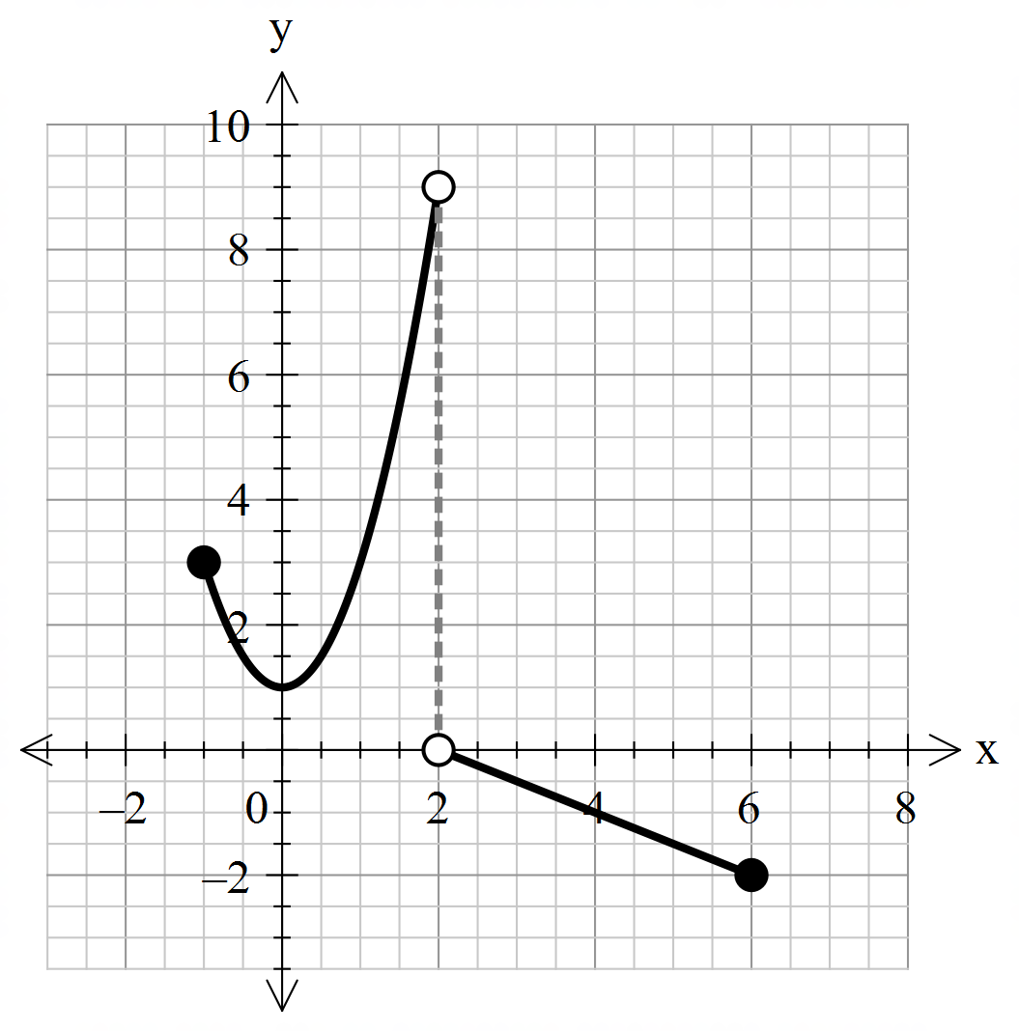

(b) State the domain and range of the function. (2 marks)

(c) On the axes provided sketch the following. (8 marks)

i) 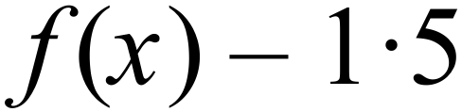

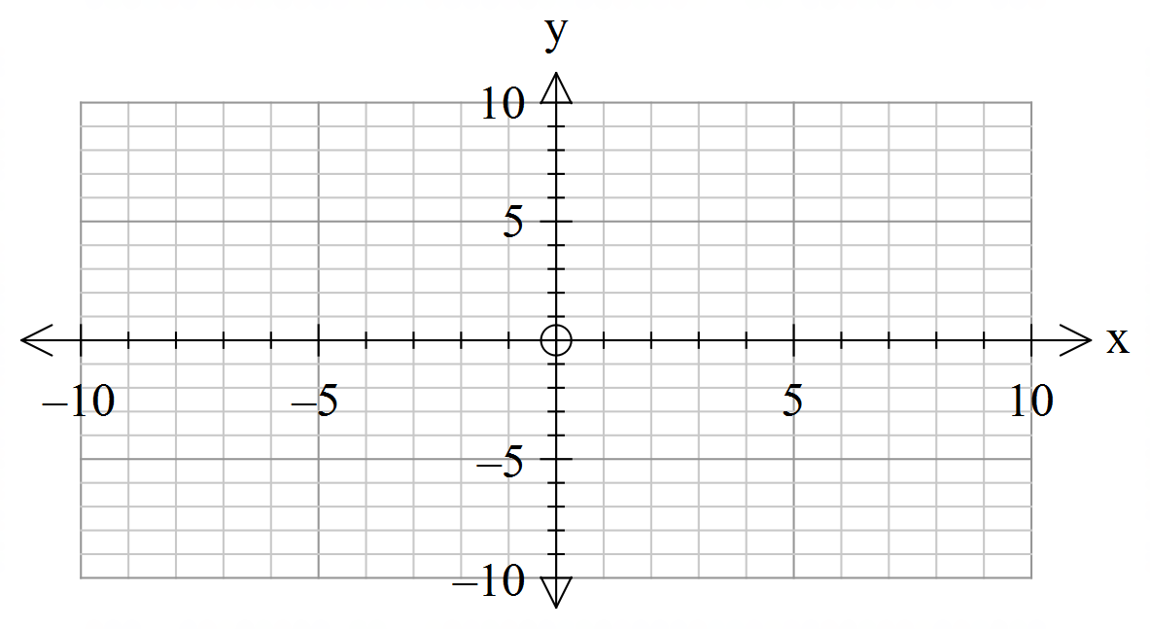

ii) 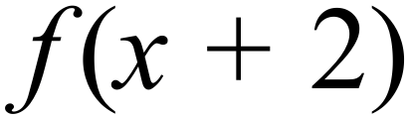

 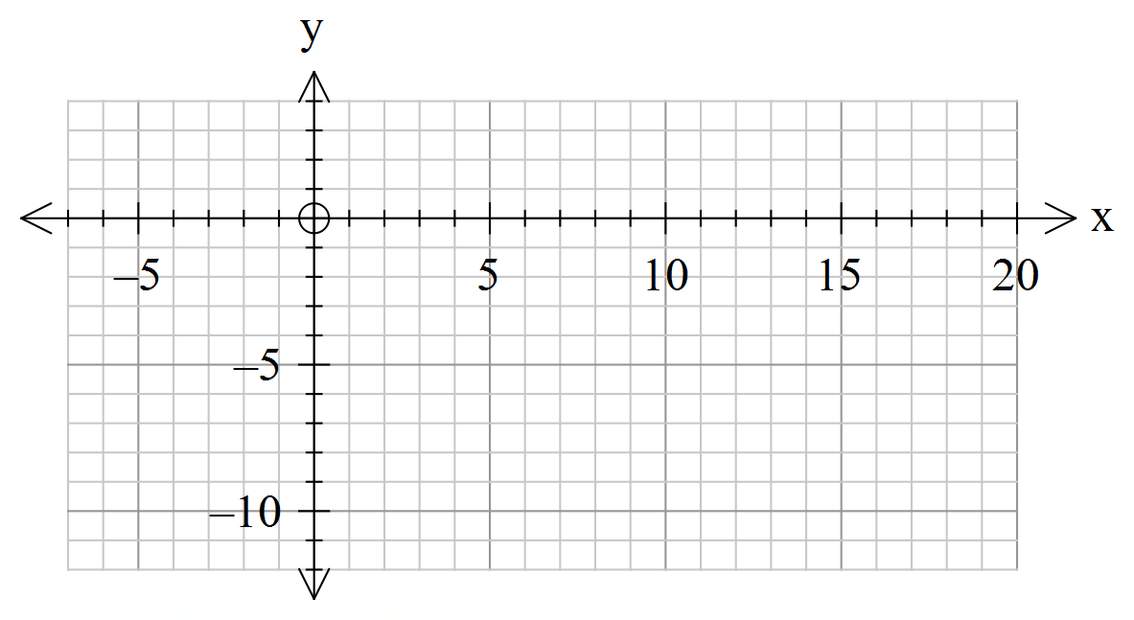

iii) 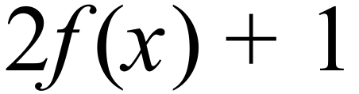

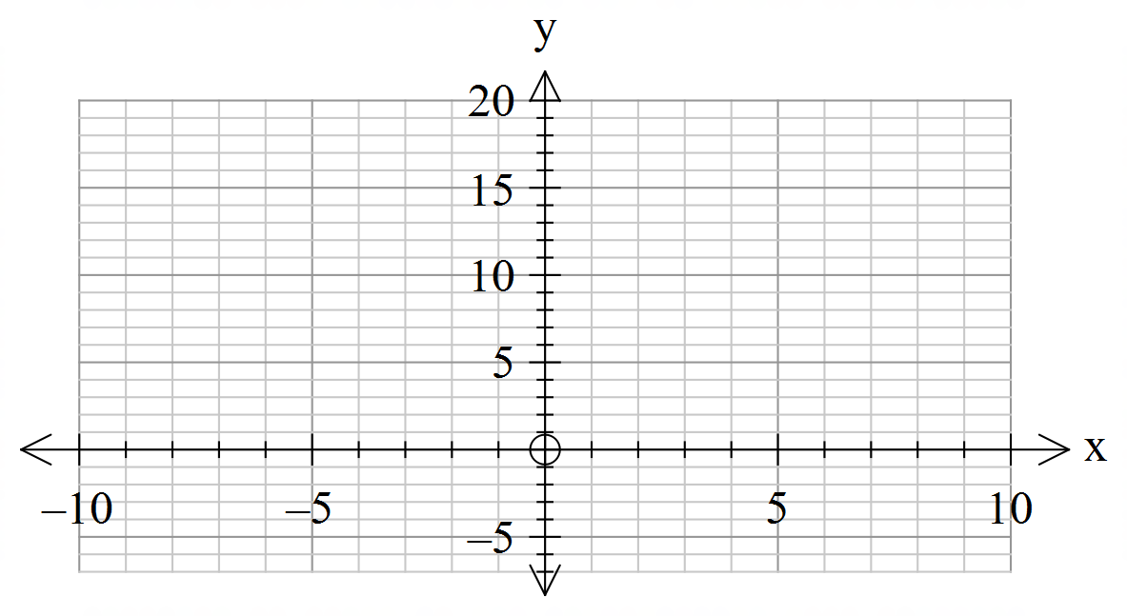

iv) 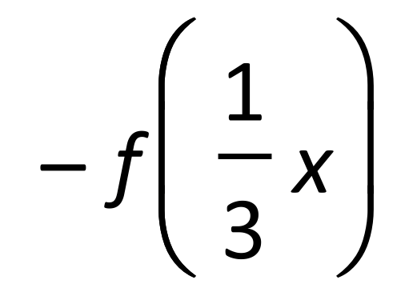

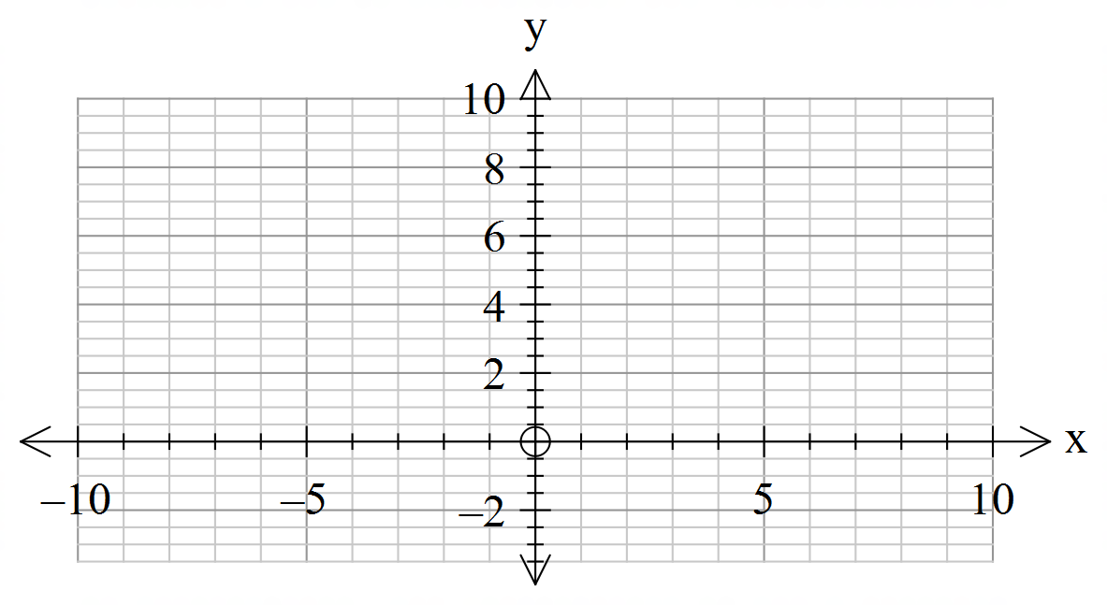

**Question 14 (5 marks)**

A quadratic function has the equation 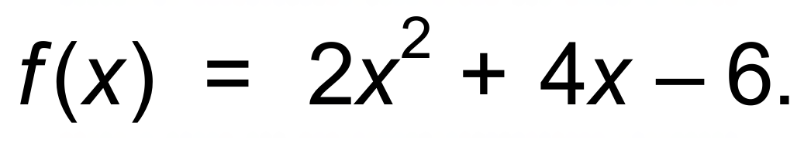

(a) Find the value of ***p*** for which the equation 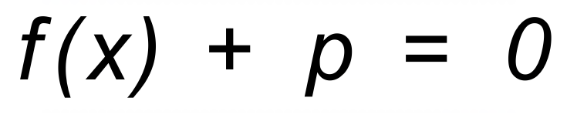 has one solution. (3 marks)

(b) Find the value of ***q*** for which 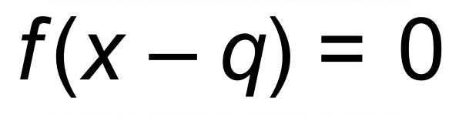 (2 marks)

i) two positive solutions.

ii) two negative solutions.

**Question 15 (8 marks)**

Find the natural Domain and Range of these functions:

(a) 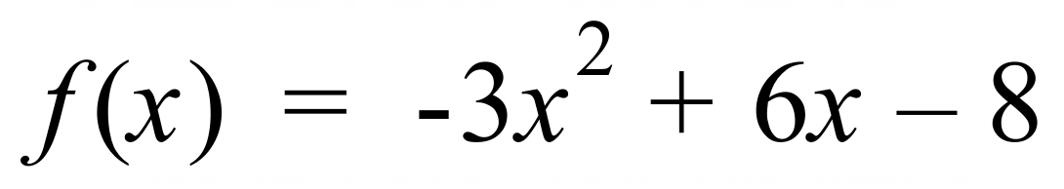 (2 marks)

(b) 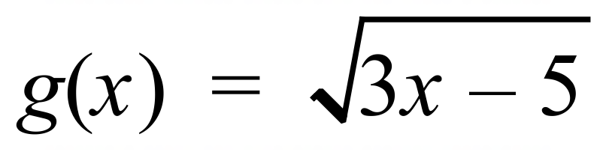 (2 marks)

(c) 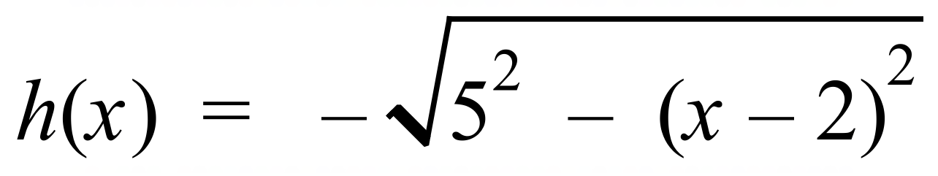 (2 marks)

(d) 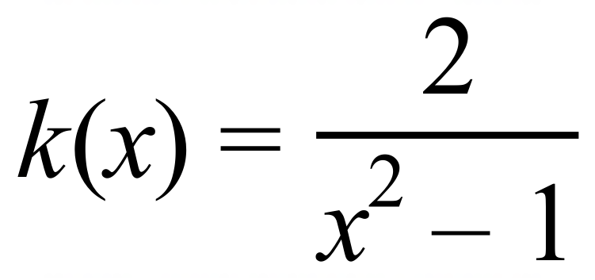 (2 marks)

**Question 16 (12 marks)**

Modern Corporation produces three products where the cost function 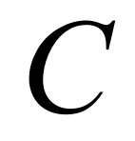 in terms of the number of items produced 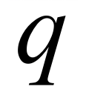 and for 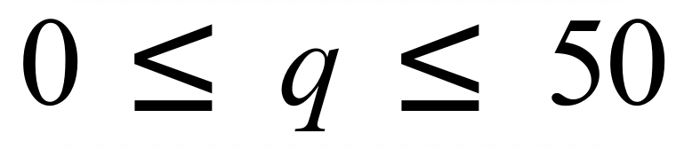 is given by:

Product 1 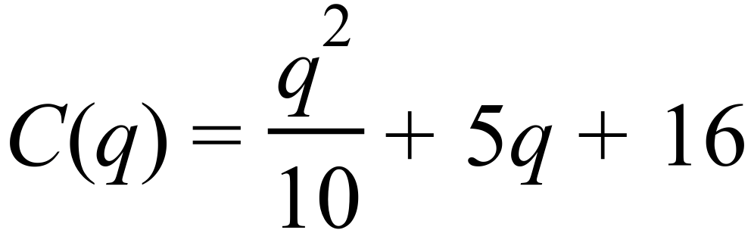

Product 2 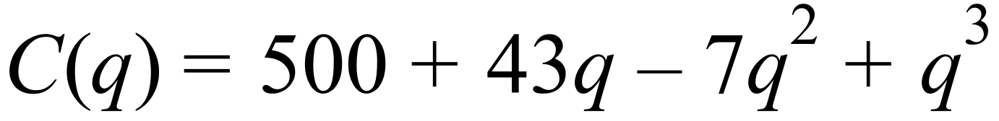

Product 3 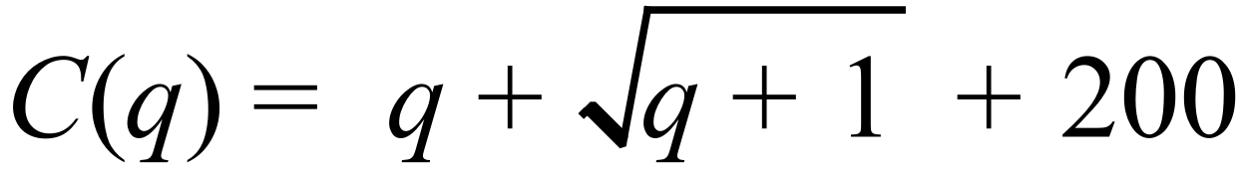

(a) Determine (6 marks)

i) the fixed costs involved in the production of each product.

ii) the total cost of producing 50 units of each product.

(b) (3 marks)

Approximately how many of each product, need to be produced so that the cost of production is $240?

(c) (3 marks)

Will the cost of production of products 1 and 3 ever be the same for a specified value of ***q***.

If so, determine the approximate value of ***q*** and the total cost of production where this occurs.

(Hint: Graph on the Classpad with a scale of :

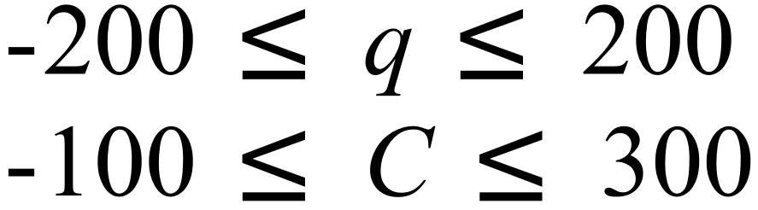 )

**Question 17 (5 marks)**

Show that the circles $x^{2}+y^{2}-2x-3y=0$ and $x^{2}+y^{2}+x-y=6$ intersect on the *x*-axis and *y*-axis.

**Question 18 (3 marks)**

Travelling at an average speed of 60km/h Dr George takes 15 minutes to reach his surgery. If he wishes to reach his surgery three minutes faster, by how much must he increase his average speed?

Additional working space

Question number:

Additional working space

Question number:

Additional working space

Question number: